**FINANCIAL FORECASTING**

SCENARIO

Developing a financial forecasting tool that predicts future values based on past data.

RECURSION

Recursion is a programming technique where a function calls itself to solve a problem. It simplifies problems by breaking them down into smaller, self-similar subproblems, making the overall solution easier to understand and implement.

IMPLEMENTATION

FinancialForecast.java

public class FinancialForecast {

    public static double forecast(double initial, double rate, int years) {

        if (years == 0) {

            return initial;

        }

        return forecast(initial, rate, years - 1) * (1 + rate);

    }

    public static void main(String[] args) {

        double initial = 10000.0;

        double rate = 0.05;

        int years = 5;

        double forecastedValue = forecast(initial, rate, years);

        System.out.printf("Future value after %d years: %.2f /-\n", years, forecastedValue);

    }

}

OUTPUT

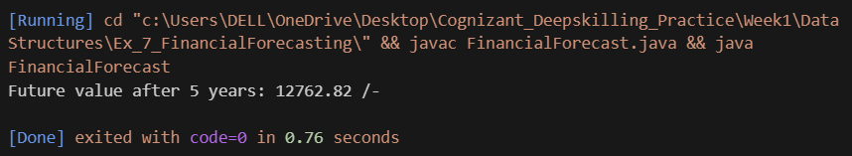

ANALYSIS

* Time complexity: O(n)
* Optimization: Store results of previous computations to prevent recalculation of same values or switch to an iterative approach